Light Board
series

NPA Nordiskt Papper AB
Svarvaregatan 11, 341 34
Sweden
08-368650
order@nordisktpapper.se
nordisktpapper.se

Light Board
User Manual

Model no. 902312 A4, 902313 A3 och
902314 A2

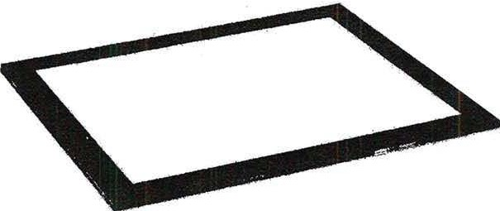

Thank you for
purchasing this light board series. This light box for drawing is brighter, stronger and smarter. Super bright LED lighting provides an evenly lit surface and gives the artist, designer, or animator a new and practical way to design, draw or sketch.

SAVE THESE INSTRUCTIONS

Important Safety Instructions
Always follow basic safety precautions when using a light board, including the following:
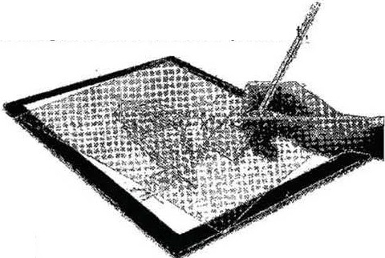
- Make sure you read and understand all instructions before use.
- Supervise use by or near children. Do not leave unattended when in use.
- Do not operate this equipment if the power cord is damaged or if the unit has been dropped or damaged in any way until it has been checked by an electrician.
- If an extension cord is used, make sure it has the correct voltage rating. A lower amperage rating than this equipment may cause overheating.
- Always unplug the equipment from the electrical outlet when not in use. Always unplug from the electrical outlet by grasping the power adapter, never pulling on the cord as this may damage the adapter or outlet.
- Do not immerse in water. If the equipment has been damaged by water, do not use it until it has been checked by an electrician.

Installation and Operation
The light table comes with 4 soft self-adhesive pads that can be attached to the bottom corners.
Remove the light table from the cabinet.
Plug the power adapter into a power outlet and then plug the adapter into the light board. Press the ON/OFF button located on the top of the light table.
Adjust the light level by pressing the ON/OFF button. The levels can be adjusted up/down in 5 steps.

Warning:
Do not cut or use sharp objects on the acrylic work surface as this will scratch and damage the surface. A transparent screen mat is recommended.

Maintenance
Clean the acrylic surface with a soft cloth and a non-abrasive cleaner, such as dishwashing liquid. Never apply cleaner directly to the light table as it may leach into the unit and cause damage.

Parts List
Name | Amount
AC adapter 110V 240V 50/60 Hz | 1
Adhesive pads | 4
Cloth bag | 1
Instructions | 1
Warranty card | 1

Warranty
This product is warranted against defects in workmanship and materials for one year from the date of purchase by the original purchaser. If any part of the equipment becomes defective under normal installation and use, it will be repaired or replaced at no additional charge provided that it is made within this period.
This warranty does not cover repair for damage to the product or product components. Failures caused by (i) abuse, neglect, power failure or interference, lightning, fire, flood or accident, (ii) use of products or accessories provided by others or (iii) failure to follow installation, operating or maintenance instructions.
For questions about the warranty, contact us at email@domainname.com.

Product Warranty Card

NPA Nordiskt Papper AB
Svarvaregatan 11, 341 34
Sweden
08-368650
order@nordisktpapper.se
nordisktpapper.se

Warranty Card
Dear customer,
thank you for choosing our product. Please keep this card in a safe place, fill it out and return it to us if necessary.

User information | Customer name:
User information | Purchase date:
User information | Phone number:
User information | Address:
Product Information | Product name:
Product Information | Product model:
Product Information | Product code:
Product Information | Manufacture date:

